**TEM Troubleshooting Guide**

**Resources**

|  |  |
| --- | --- |
| **Engagement Report** |  |
| **Per Diem** |  |
| **Workbook Rules** |  |

**Quick Summary: Travel and Expense is comprised of three components.**

1. TEM server
2. Allows you to log in and administer TEM server if you’re administrator.
3. Allows user to log in and create authorization/expense reports
4. Drools engine
5. Business rules setup. Governs perdiem/expense/tax/etc. rules.
6. Workflow server
7. TEM triggers workflow to perform action items, primarily email notification to the approver and travelers with a link to log into workflow and complete certain items so that the report is approved.

**Possible reasons why TEM is down**

1. **Database disconnection**
2. **Drools disconnection**
3. **Workflow disconnection**

**KILLING TEM/WEBLOGIC INSIDE LINUX SHELL**

I’m not sure why our instances of fusion middleware don’t have a graceful way of shutting down weblogic. You’re going to have to ask Noemi why if you’re curious. You’re going to have to kill weblogic then get things back up again.

Restarting fusion middleware:

Log into TEM server hermes (dev8) or chronus (live8).

Type “ps aux” to see processes and locate weblogic and or other items that java is running.

Use “pkill java” to kill all java related processes. This will wipe out weblogic entirely but there is also a possibility that there are some locked files “*.lok” that will prevent you from starting up the servers in weblogic properly.

So run the following command: **find ./ -name ‘*lok’** to find any locked files then delete them all. If you feel uneasy about deleting the files you can also rename it to something like *.lok.old.

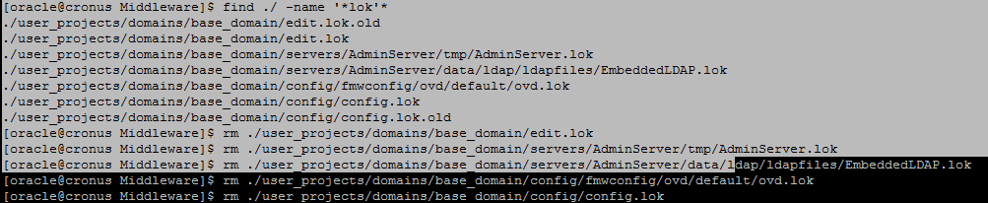

Remember to run the OPMN. It stands for the Oracle Process Manager and Notification Server. You will need to run this in order for the oracle wallet to function otherwise SSL will be down and any visitors that visit TEM will not be able to gain access.

**OPMN Path**/home/oracle/Oracle/Middleware/Oracle_WT1/instances/instance1/bin/  
**Stoping OPMN**  
Opmnctl stopall  
**Starting OPMN**  
Opmnctl startall

You can always type “ps aux” to see the processes that are running in the back ground.

**LOGGIN INTO WEBLOGIC CONSOLE IN CASE YOU NEED TO RESTART SERVERS**

Once all the above is done you can now visit the weblogic console by going to

<http://cronus.westernu.edu:7001/console> - LIVE

<http://hermes.westernu.edu:7001/console> - DEV

Quick note, you’re going to have to start up the drools engine first so that when you start the TEM server it will try to contact the drools engine first and if the engine isn’t up, none of the business rules for the perdiem meals/expenses will be recognized and you’re going to have to redo the starting of the application servers.

Steps to start application servers back up. You’ll need to start up the drools server first, then TEM otherwise the business rules for meals/taxes/etc will not work. Workflow is an independent server so you do not need to restart workflow if it already is working without issues.

1. On the Domain Structure, click on Environment.
2. Environment link will expand and show a bunch of other links, now click on Servers.
3. Summary of Servers will show, now click on the Control tab.
4. Click the checkbox for droolsSMPL then hit the start button. It should take about 1-2 minutes to start up the server.

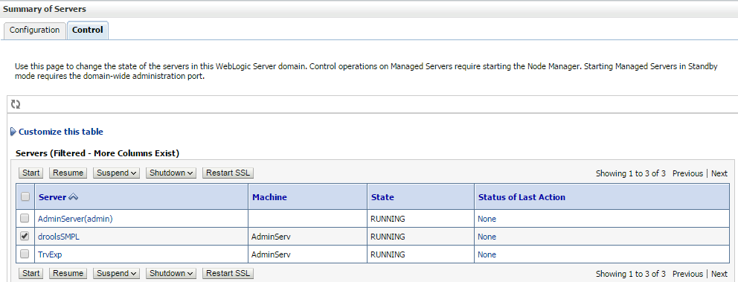

1. Click on TrvExp checkbox, uncheck drools SMPL and then hit start. This should also take 2 minutes or so to launch.

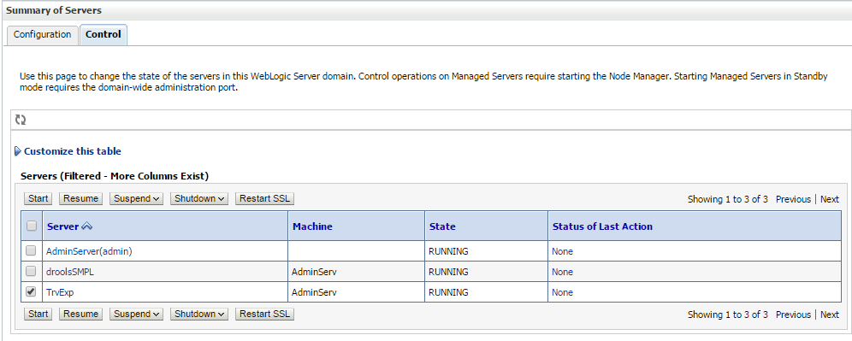

The state for both servers should be “running” which means they are good to go for use.

1. Now visit the following links to see if TEM is back up:

<http://hermes.westernu.edu:37004/tvlexp/tvlexp-flex/index.jsp> (DEV8)

<https://cronus.westernu.edu:4443/tvlexp/tvlexp-flex/index.jsp> (LIVE8)

**REMINDER: If you are unable to start up the server please make sure that any *lok files have been deleted or renamed prior to being able to use the administration portion properly. You’re going to notice a lot of lag when trying to visit a particular link etc within the admin portal and this is usually caused by a timeout from trying to access the lok files. If in doubt, please check the log files, which will offer more than adequate evidence on what may be preventing you from getting the server back up and running.**

**Log file locations:**

**Weblogic logs**/home/oracle/Oracle/Middleware/user_projects/domains/base_domain/tvlexp.log

**Drools logs**/home/oracle/Oracle/Middleware/user_projects/domains/base_domain/servers/droolsSMPL/logs/droolsSMPL.log

**TEM logs**/home/oracle/Oracle/Middleware/user_projects/domains/base_domain/servers/TRvAndExp/logs/TRvAndExp.log

**AdminServer**/home/oracle/Oracle/Middleware/user_projects/domains/base_domain/servers/AdminServer/logs/AdminServer.log

**Past problems and solutions**

**Problem**User is unable to submit an authorization or expense report. Gives you an error about contacting the workflow server.  
**Solution**Check to see if workflow user has a matching email address as what is on file with in Goremal table. If one doesn’t exist, merely create one and that should allow TEM to submit to workflow without issues.

**Problem**Delegate unable to add per diem meals even though a meal falls in the period of the travel day  
**Solution**Current solution is to fall back or forward on the time until you are able to add the per diem meals. Seems to be an issue with the drools guvnor engine. Working with Ellucian on resolving this.  
  
**Problem**Unable to attach a file  
**Solution**BDM (Banner Document Management) may be down. Once the server is back up and contactable you should be ok to attach and retrieve attachments

**Problem**  
Unable to attach a file larger than 1kb in file size  
**Solution**  
Seems to be a server configuration issue, possible because of SSL certificate. Ask Noemi about this.  
  
**Problem**  
Drools then TEM servers started back up in correct order but unable to visit TEM login page.  
**Solution**  
opmnctl needs to be started otherwise SSL is not working and nobody will be able to access the login page.  
  
**Problem**No connection to the server

**Solution**If there is no established connection, make sure the server is reachable and if not contact the guys downstairs to see if anything has been changed.